

**Name: Golden Horizon**

**Price: 1250$/hour**

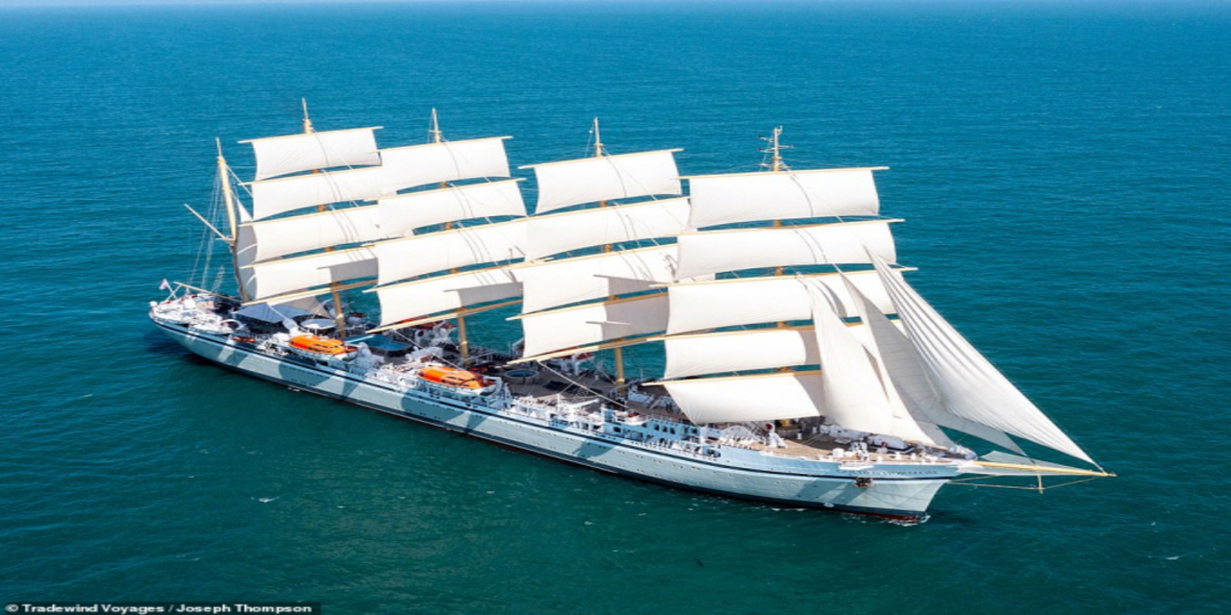

The world’s largest square-rigged sailing ship, Golden Horizon, offered her first voyages in May 2021. The luxurious ship will carry up to 272 passengers. Golden Horizon is a near replica of the 1913-built ocean vessel France II and will retain its historic charm. Golden Horizon will allow guests to explore the world and the oceans in a more sustainable way.

A highlight of the first season will be a British Maritime voyage, with the ship anchoring off Cowes for the traditional Regatta fireworks display. In total, nine voyages will be offered from the UK with seven departures from Harwich and two from Glasgow. Northern European itineraries will feature Denmark, Iceland, the Norwegian Fjords and the Baltics. In September 2021, Golden Horizon will sail to the other side of the world, taking guests on an adventure that will include some beautiful and rarely visited islands along with unique and iconic destinations. Initially, she will travel east through the Suez Canal and follow the historic Maritime Silk Route to Jakarta, and on to Bali. Itineraries in late 2021 and into 2022 will feature Australia, the Indian Ocean, Japan, Alaska, the Americas and the Pacific Islands.

|  |  |
| --- | --- |
|  |  |
|  |  |
|  |  |
|  |  |

|  |
| --- |
| ***​*** |
|  |
|  |

***​DESCRIPTION***

|  |  |  |  |
| --- | --- | --- | --- |
|  | **Long 50m** |  | **Wide 10m** |
|  | **25 Room** |  | **48 Owner & guest** |
|  | **1 x 300 HP** |  | **12 - 34 Knots** |
|  | **Day Charter** |  | **30 L/h** |

ROAD CHARTER

»» Sightseeing on the Saigon River by yacht in 2 hours.  
1. Sunset and city night life.  
2. Enjoy the freedom & fresh air.  
  
»» Saigon – Can Gio Mangrove Forest 4 hours.  
1. Enjoy the mangrove forest and the life of local fisherman.  
2. Buy and cook local seafood from the forest fisherman. The special seafood of brackish water.  
3. Sunset on the river  
4. Night life of the city  
  
»» Saigon – Vung Tau City  
1. The trip will go through Can Gio Mangrove Forest.  
2. Swimming in the open sea (near the coastine)  
3. Sunset on the river  
4. Night life of the city